**Tribhuvan University**

**Faculty of Humanities and Social Science**

DevicePoint (Electronic Gadget E-Commerce Management System)

A PROJECT REPORT

**Submitted To**

Department of Computer Application

Shahid Smarak College

*In partial fulfillment of the requirements of the Bachelors in Computer Application*

**Submitted by: -**

Surendra Bohara (26202026)

November 2025

Under the Supervision of

**Mr. Hari Lal Chalise**

Tribhuvan University

Faculty of Humanities and Social Sciences Shahid Smarak College

Supervisor’s Recommendation

I hereby recommend that this project prepared under my supervision by **SURENDRA BOHORA** entitled “**DevicePoint**” in partial fulfillment of the requirements for the degree of Bachelor of Computer Application is recommended for the final evaluation.

…………………

**Mr. Hari Chalise**

SUPERVISOR

Shahid Smarak College

Kirtipur, Nayabazar

Tribhuvan University

Faculty of Humanities and Social Sciences Shahid Smarak College

Letter of Approval

This is to certify that this project prepared by **SURENDRA BOHORA** entitled “**DevicePoint**” in partial fulfillment of the requirements for the degree of Bachelor in Computer Application has been evaluated. In our opinion it is satisfactory in the scope and quality as a project for the required degree.

|  |  |
| --- | --- |
| ………………….  Mr. Hari chalise **Supervisor**  Shahid Smarak College Kirtipur, Nayabazar | …………………. Mr. Sanjay Jnawali **Coordinator**  Shahid Smarak College Kirtipur, Nayabazar |
| ………………….  **Internal Examiner** | …………………. **External Examiner** |

Acknowledgement

I would like to express my sincere gratitude and appreciation to the following individuals and organizations for their valuable support and contributions for this project.

First and foremost, i would like to thank our Shahid Smarak Collage for providing the opportunity to participate in the Project Second. This project has been instrumental in helping us gain knowledge and skills in the field of web and application development.

Secondly, I would like to thank Mr. Hari Chalise sir who provided guidance and support throughout the project. His expertise and dedication to teaching the concepts of web development have been instrumental in my learning process. The guidance and expert opinions have been instrumental in analysing the trends, challenges, and opportunities surrounding online food ordering. Finally, I would like to thank our Shahid Smarak family and friends for their unwavering support, encouragement, and belief in my abilities throughout the project.

Thank you, to everyone mentioned above and to all others who have contributed in various ways, i extend my sincere thanks. Your collective efforts have enriched our understanding of online shopping. Your support and contributions are greatly appreciated.

Thank you all for being a part of this exciting journey.

Yours Sincerely,

Surendra Bohora

Abstract

DevicePoint is a comprehensive web-based e-commerce solution specifically designed to streamline the buying and selling of electronic gadgets, including smartphones, laptops, and smartwatches. Built to meet the increasing demand for digital shopping, the platform offers a centralized environment where users can explore a wide range of products, compare technical specifications, and make informed purchasing decisions without visiting a physical store. The system emphasizes easy navigation, reliable performance, and secure handling of customer data to ensure that every interaction—from browsing products to complete a smooth and efficient transaction. Its design incorporates responsive layouts that adapt seamlessly across devices, enhancing accessibility for both desktop and mobile users. On the administrative side, DevicePoint provides robust management tools that allow system administrators to efficiently control product listings, update categories, monitor customer orders, and oversee user accounts. These backend features support smooth business operations and help maintain accurate and up-to-date information across the platform. Customers benefit from a well-structured interface that enables them to search products by category, review detailed descriptions, add items to their cart, and proceed through a secure checkout process. The system also integrates essential e-commerce functions such as inventory handling, real-time product availability, and order status tracking, contributing to transparency and user trust. Overall, DevicePoint operates as a complete and dependable solution for managing an online electronics store. By balancing functionality, speed, and security, it enhances the digital shopping experience while providing an efficient workflow for administrators. Its goal is to make gadget purchasing more convenient, reliable, and engaging for a wide range of users.

**Keywords:** *DevicePoin, E-commerce platform, Electronic gadget marketplace, Online electronics store, Mobile, Digital shopping experience, Digital shopping*

Table of Contents

Supervisor’s Recommendation i

Letter of Approval ii

Acknowledgement iii

Abstract iv

Chapter 1: Introduction 1

1.1 Introduction 1

1.2 Problem Statement 1

1.3 Objectives 1

1.4 Scope and limitation 2

1.5 Report Organization 2

Chapter 2: Background study and Literature Review 3

2.1 Background study 3

2.2 Literature review 4

Chapter 3: System Analysis and Design 5

3.1 System Analysis 5

3.1.1 Requirements Analysis 6

3.1.2 Feasibility Analysis 7

3.1.3 Data Modeling (ER-Diagram) 8

3.1.4 Process Modeling (DFD) 9

3.2 System Design: 11

3.2.1 Architectural Design 12

3.2.2 Database Schema Design 12

3.2.3 Interface Design: 13

3.2.4 Physical DFD 16

3.2.5 Algorithms 16

Chapter 4: Implementation and Testing 17

4.1 Implementation 17

4.1.1 Tools Used 17

4.2 Testing 22

4.2.1 Test case for unit testing 22

4.2.2 Test Case for System Testing 26

Chapter 5: Conclusion and Future Recommendation 27

5.1 Lesson Learnt/ Outcome 27

5.2 Conclusion 27

5.3 Future Recommendations 27

• Add advanced recommendation algorithm 27

• Add features of record for daily ordered food items. 27

References 28

**List of Tables**

Table 4.1: Register page test case 22

Table 4.2: User Login Test Case 23

Table 4.3: Food Search Test Case 24

Table 4.4: Food Order Test Case 24

Table 4.5: Login Test Case for Admin 25

Table 4.6: Admin Order Test Case 25

**List of Figure:**

Figure 3.1: Waterfall Model 5

Figure 3.2: Use Case diagram 6

Figure 3.3: Gantt chart 8

Figure 3.4: ER Diagram 9

Figure 3.5: DFD level 0 10

Figure 3.6: DFD level 1 10

Figure 3.7: DFD Level 2 11

Figure 3.8: Architectural Design 12

Figure 3.9: Database Schema 13

Figure 3.10: Dashboard 13

Figure 3.11: Manage Amin 13

Figure 3.12: Add new category 14

Figure 3.13: Manage order 14

Figure 3.14: User registration 14

Figure 3.15: User Login 15

Figure 3.16: Categories 15

Figure 3.17: Physical DFD level 1 16

List of Appendices

Appendix 1: Featured Categories 29

Appendix 2: Recommended Foods 29

Appendix 3: Food Menu 30

Appendix 4: Categories 30

Appendix 5: User Login 31

Appendix 6: Manage Food 32

Appendix 7: Add Category 33

Appendix 8: Order Details 33

List of Abbreviation

|  |  |
| --- | --- |
| CSS | Cascading Style Sheet |
| ER | Entity Relationship |
| HTML | Hyper Text Markup Language |
| HTTP | Hypertext Transfer Protocol |
| JS | JavaScript |
| MySQL | My Structured Query Language |
| PHP | Hyper Text Preprocessor |
| SQL | Structured Query Language |

# Chapter 1: Introduction

## **Introduction**

DevicePoint is a modern web-based e-commerce system designed to provide users with a seamless and convenient online shopping experience for electronic gadgets such as mobile phones, laptops, and smartwatches. As digital buying trends continue to rise, DevicePoint aims to bridge the gap between consumers and technology by offering a centralized platform where customers can explore, compare, and purchase the latest electronic devices from the comfort of their homes.

This system focuses on delivering a user-friendly interface, secure transactions, efficient product management, and real-time interaction between customers and the store. DevicePoint enables administrators to manage categories, products, orders, and user accounts with ease, ensuring smooth business operations. Meanwhile, customers can browse products, view detailed specifications, add items to their cart, and place orders with a straightforward checkout process.

By integrating essential e-commerce functionalities with responsive design and a reliable backend, DevicePoint serves as a complete solution for managing an online electronics store. Its goal is not only to simplify gadget shopping but also to enhance the overall customer experience through speed, accuracy, and transparency.

## Problem Statement

The online food ordering/delivery industry while experiencing significant growth, faces several challenges that hinder the seamless interaction between consumers and the virtual marketplace.

* Consuming lots of time for physical restaurants
* Limited system for digital marketplaces.

## Objectives

* To develop the system that connect consumer and online gadgets.
* To provide secure and scalable system with increasing customers demand
* To enhance user experience.
* To improve Customer Engagement.

## Scope and limitation

**Scope**

* Easier system to use, people with little bit of knowledge about system can use.
* Enhance thorough websites and intuitive interfaces.
* Provide local gadgets and electronic vendors with a platform to reach more customers

**Limitation**

* Lack of advanced recommendation algorithms.
* Lack real-time chat support, or dynamic discounting.
* Limited advanced features.

## 1.5 Development Methodology

The Agile methodology was selected for this project due to its iterative, flexible, and user-centered approach. Agile focuses on developing the system in small, functional increments, allowing continuous feedback, testing, and improvement. This model provides flexibility and in this project each module like product management, shopping cart are developed, tested and deployed separately.

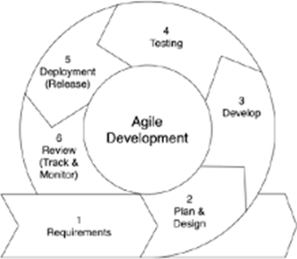

Figure 1:1 Agile Methodology

## 1.6 Report Organization

**Chapter 1: Introduction**

This chapter serves as the project's inception, offering a comprehensive overview. It introduces the project, outlining the problem statement, objectives, and the scope and limitations of the endeavor. Its purpose is to provide readers with a solid grounding in the project's context and objectives.

**Chapter 2: Background Study and Literature Review**

Focusing on contextual understanding, this chapter delves into the background study and literature review. It delves into existing similar projects and relevant concepts that underpin the current undertaking. By exploring previous research, this chapter enriches readers' comprehension of the project's foundations.

**Chapter 3: System Analysis and Design**

Centered on the project's operational aspects, this chapter delves into system analysis and design. It encompasses feasibility analysis, functional and non-functional assessments, schema and architectural design, as well as data and process modeling diagrams. This chapter provides a comprehensive insight into the intricacies of the project's functionality.

**Chapter 4: Implementation and Testing**

This chapter is dedicated to the practical realization of the project. It encompasses the implementation and testing phases, which include the creation of test cases to verify the proper functioning of the system's components. Furthermore, it outlines the tools and

**Chapter 5: Conclusion and Future Recommendations**

The concluding chapter encapsulates the culmination of the project's journey. It presents a succinct summary of the project's outcomes and achievements. Additionally, it offers insightful recommendations for future advancements and enhancements. This chapter serves as a forward-looking conclusion, reflecting on the project's impact and potential for growth.

# Chapter 2: Background study and Literature Review

## Background study

During the development of this project, I researched and studied a couple of existing systems, they are listed below.

**FoodMandu** is one of them which is most famous in Kathmandu valley whose provide food delivery system on valley area and Pokhara or Chitwan. But this website lacking on limited reach, there are many other big cities in Nepal where there is no any food ordering system [1].

**Bhojdeals** is a prominent food delivery platform in Nepal, especially popular in the Kathmandu Valley. Launched in 2015, it connects users with a wide range of restaurants, allowing them to order food online through its website or mobile app (available for Android and iOS). Bhoj Deals operates from 10 AM to 8:30 PM, which might not cater to late-night craving. Another problem is high charge on smaller orders [2].

**Swiggy** is a leading food delivery platform in India. It offers a robust platform connecting customers with a wide array of restaurants, grocery stores, and convenience services. It has issues in customer service which are reported by users [3].

## Literature review

We search into and examined a few relevant websites and applications for this project. We learn from the research that there aren't many websites or web-based applications related to online food ordering system.

Author in [4] says about the use of online meal ordering services is becoming a common practice in Australia, and it is therefore important to implement evidence-based strategies and policies to encourage individuals to make healthy food choices when using these services.

Author of [5] talk that the convenience of users is the primary objective aspect of such, while the second thing that these software's are also beneficial for the development of the market in eating and food supply, as the use of the online platform is a place where the restaurant owner is prepared to attract as many users as he can by allowing them to see the entire food menu in accordance with item name, price, photo, etc.

Author in [6] found that during the global 2020 COVID-19 outbreak, the advantages of online food delivery (FD) were obvious, as it facilitated consumer access to prepared meals and enabled food providers to keep operating.

Author in [7] says that meals ordered online for home delivery are typically less healthy than home-made meals, potentially contributing to weight gain.

# Chapter 3: System Analysis and Design

## 3.1 System Analysis

System analysis is a phase in the development of information systems where analysts examine and evaluate the current system or the proposed system to identify problems, opportunities, and solutions [8]. The primary goal is to understand how the system works, what it should accomplish, and how it can be optimized or improved. The process by which systems are developed can be described by the systems development life cycle. This is the initial phase for any software being developed in waterfall software development model.

This system will be following the waterfall software development methodology. As shown in the figure below, we will be developing the system in five different phases.

figure 3:1 agj;kg

figure 3:2

3:3water

Figure 3:4ex

**Figure 3.1: Waterfall Model**

## 3.1.1 Requirements Analysis

Requirement analysis is a critical phase in the software development life cycle where the needs and expectations of users and stakeholders are gathered and documented. The goal is to define the functional and non-functional requirements that the software system must meet.

#### **Functional requirements.**

* Customers can add to cart, Wishlist and search as their needs.
* Admin can change the status of item order.
* Admin have full control over the category, add new product items, and delete them as well.

#### **Non-Functional requirements.**

* **Availability**:

The users can easily access anytime, anywhere just through a smartphone or a PC and an internet connection. The system will run 24/7.

* **Security:**

The user’s information isn’t shared to others. Only authorized users can access the system with username and password. Only valid users can access to the system. All the admins passwords are encrypted.

* **Performance:**

This system is designed for smooth performance with good optimization and good response.

* **Reliability:**

The data of user will be private and they can login with theirs username and password after registration.

## 3.1.2 Feasibility Analysis

Feasibility analysis is an essential step in the decision-making process for various projects, initiatives, or business ventures. It involves evaluating the practicality, viability, and potential success of a proposed idea before investing time, resources, and money. The primary goal of feasibility analysis is to assess whether the project is worth pursuing and to identify potential challenges or risks.

Following feasibilities were studied before building the system:

#### **Technical Feasibility:**

The system was developed and checked in functional device and good quality of internet.

1. **Operational Feasibility:**

This system uses simple technologies to design. So, it is user friendly. To operate this system there is no need to advanced knowledge of coding and expert in web technology. Any person who have simple knowledge about computer can operate.

1. **Economic Feasibility:**

This system doesn’t require extra software and hardware i.e., it uses open-source technologies. So, there is no extra cost rather than internet. But for database and hosting can effect on budget.

In this project, Gantt chart is used for Schedule feasibility study.

**Gantt chart:**

**Figure 3.3: Gantt chart**

In the figure 3.3, it shows the start and finish dates of the project elements such as planning, analysis, design, coding, testing, bug fixing, and delivery. It clearly shows that the project started from June 20 and ended on August 28. It almost took 4 months to complete the whole project.

### 3.1.3 Data Modeling (ER-Diagram)

ER diagram is a visual representation of the data model that represents the logical structure of a database [9]. This is based on three basic concepts: entities, attributes and relationship of this project, which show how data model is represented.

**Figure 3.4: ER Diagram**

### 3.1.4 Process Modeling (DFD)

For graphical representation of the “flow” of data through an information system, modeling its process aspects following DFDs are used for analyzing and depicting the flow of data within a system.

**DFD Level 0** provides basic overview of a system, illustrating major processes, data sources, data destinations, and the flow of information between them.

**Figure 3.5: DFD level 0**

DFD Level 1 expands on the Level 0 by breaking down major processes into sub-processes, depicting detailed data flows, and showing data stores and external entities involved.

**Figure 3.6: DFD level 1**

At DFD Level 2, each process from DFD Level 1 is decomposed into more detailed sub processes. It includes data stores, data sources, data destinations, and detailed data flows, providing a more comprehensive representation of the system's internal processes.

**Figure 3.7: DFD Level 2**

## 3.2 System Design:

System design phase is used to create the blueprint of the requirement gathered during the analysis phase. The primary goal is to achieve the blueprint of this project in detail. System Design is the process of designing the architecture, components, and interfaces for a system so that it meets the end-user requirements. This specifically designed to learn and system Design concepts in the most efficient way from basics to advanced level.

### 3.2.1 Architectural Design

Designing the architecture for this project involves determining the structure and organization of the system components to meet the specified requirements. This phase of design will be planning the architecture of the application. The business layer will be totally independent. Data will be stored in an SQL database. Database helps to store the data. To query the database and code behind for server-side scripting will be in PHP. The other business objects will have their own layer. The architecture of the application is shown in the figure.

**Figure 3.8: Architectural Design**

### 3.2.2 Database Schema Design

A database schema defines its entities and the relationship among them which are used in this project. It contains a descriptive detail of the database, which can be depicted by means of schema diagrams. It’s the database designers who design the schema to help programmers understand the database and make it useful.

**Figure 3.9: Database Schema**

### 3.2.3 Interface Design:

**Admin:**

**Figure 3.10: Dashboard**

**Figure 3.11: Manage Amin**

**Figure 3.12: Add new category**

**Figure 3.13: Manage order**

**User:**

**Figure 3.14: User registration**

**Figure 3.15: User Login**

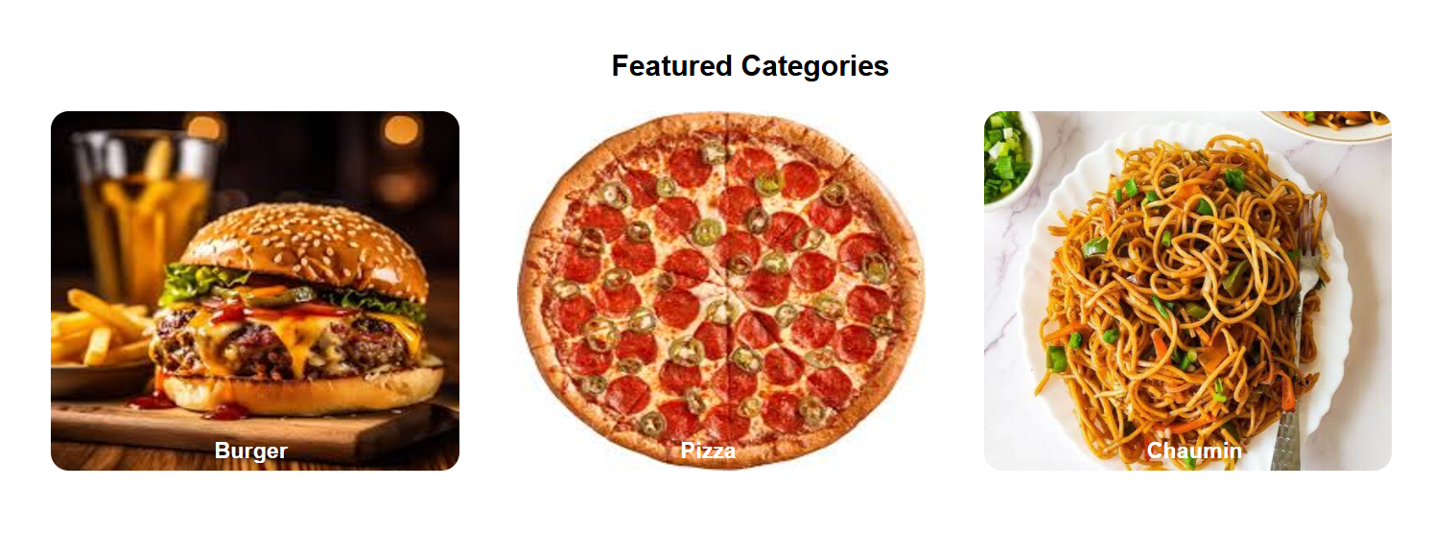

**Figure 3.16: Categories**

### 3.2.4 Physical DFD

A DFD represents a detailed, real-world view of a system, including hardware, software, databases, and network components. It illustrates how data moves physically through the system's architecture.

**Figure 3.17: Physical DFD level 1**

### 3.2.5 Algorithms

**Recommendation Algorithm**

This algorithm shows all the data when a user order any food items. If user order food, this algorithm check all the order history and select all the food items from category which is user chose in past.

# Chapter 4: Implementation and Testing

## 4.1 Implementation

Implementation includes user notification, user training, installation of hardware, installation of software onto production computers, and integration of the system into daily work processes. This phase continues until the system is operating in production in accordance with the defined user requirements.

### 4.1.1 Tools Used

Various system tools that have been used in developing both the frontend and backend have been discussed in this chapter.

**FRONT END**

#### **HTML**

HTML is the standard markup language for documents designed to be displayed in a web browser. It is used to design front-end structure. In front-end HTML is used to structure and display text content, create lists, hyperlinks, forms, use semantics like <header>, <section>. HTML provides the essential structure and markup for content on this project.

* **CSS**

This is used in this project for styling HTML elements as per our required, specifying color, font size, background color, margins, and padding. It’s used to control the layout and positioning of elements on front end. It is essential for controlling the visual presentation of pages, making them more attractive, reliable, and user-friendly.

* **JavaScript**

It is used to scripting in front-end such as event handling for example alert message.

* **Bootstrap**

In this project bootstrap helps to use pre-style HTML, and CSS components such as navigation bars, buttons, forms, modals. To use Bootstrap in project I’m include the Bootstrap file in my HTML document by linking to the Bootstrap content delivery network.

**BACK END**

* **PHP**

It is used to generating dynamic content on this project. Also used to connect to database, execute queries and process results. It’s basically used in server-side scripting.

* **MYSQL**

MySQL is utilized to manage critical aspects of the online shoe platform, including storing information about users, product details, orders, and inventory.

**4.1.2** Implementation Details of Modules

After the design was made and the problems arising from the design process were clarified and dealt with, it was time to start implementing the application. Implementing application this scale requires lots of resources and explaining the whole implantation process will not be clarified in this paper. However major important aspects in the implementation will described. Some modules of the shopping websites are listed below:

**Header:** It shows the logo of the website. The button is used to provide links to other pages which are used to select food items, categories, view ordered details etc.

**Register Form:**  It is used to register new users to the website. It contains the text fields like username, email, phone number, and password. The information entered by this registration form is further stored to be used in the login page. Only registered users can login by providing their registered name/email with corresponding valid password.





**Login Form:** It is used to allow users to securely access restricted areas or personalized features of a website. It used data like username or email and password from register from to authenticate the user and give further access.



**Food menu:** It displays the name of the food, price, description and button for order.



**Admin Module:** It provides information to the admin. It gives information about admin details, available categories and food items their featured and active status. It also gives the total number of user that are registered. Admin can add, update and remove the category and food item.

**Categories:** it shows the available food categories. Users can select different types of foods as per their interest. And on the home they can found recently launched product of all categories.

## 4.2 Testing

Testing phase for the online shoe store is to ensure a seamless and reliable shopping experience for users. Testing is done to check the behavior of a complete and fully integrated software product based on the software requirement specification document. Testing is manly use to improve and check the quality of software. We will not carry out all types of tests for the application considering the time scale to present this project. Hence is use to increase the performance of software whether it fulfilled all its need or not. We will focus the test cases on functionality, security, and performance so that various types of testing procedures were performed in order to check the working mechanism and correctness of the system.

### 4.2.1 Test case for unit testing

**Register page test case**

**Table 4.1: Register page test case**

|  |  |  |  |  |  |
| --- | --- | --- | --- | --- | --- |
| ID | Test Case  Description | Test Data | Expected  Result | Actual  Result | Pass/Fail |
| 1 | User enters a new email for register | Email: sita@gmail.com | Register Successfully | Register Successfully | Pass |
| 2 | User enter already used email for register | Email: suren@gmail.com | This email is already token | This email is already token | Pass |

**Login Page Test Case for User**

**Table 4.2: User Login Test Case**

|  |  |  |  |  |  |
| --- | --- | --- | --- | --- | --- |
| **ID** | **Test Case**  **Description** | **Test Data** | **Expected**  **Result** | **Actual**  **Result** | **Pass/Fail** |
| 1 | User enters a wrong email | Email:  ss@gmail.com  Password:1230 | Incorrect email/  username  /password** | incorrect email/  username  /password | Pass |
| 2 | User enters a wrong password | Email: suri@gmail.com  Password:suri.123 | ** incorrect email/username/password** | incorrect email  /username  /password | Pass |
| 3 | User enters valid email and password | Email:  suri@gmail.com  Password: 123 | Login Successfully | Login  Successfully | Pass |

**Food Search Test Case for User**

**Table 4.3: Food Search Test Case**

|  |  |  |  |  |  |
| --- | --- | --- | --- | --- | --- |
| **ID** | **Test Case**  **Description** | **Test Data** | **Expected**  **Result** | **Actual**  **Result** | **Pass/Fail** |
| 1 | User insert keyword  With unmacho to food items name and description | Bread | No food found! | No food  Found! | Pass |
| 2 | User insert keyword with match with only food item name | Burger | Show food item | Show Food item | Pass |
| 3 | User insert keyword which match with description of food item | Onion Capsicum Pizza | Show food item | Show food item | Pass |

**Make order Test Case for User**

**Table 4.4: Food Order Test Case**

|  |  |  |  |  |  |
| --- | --- | --- | --- | --- | --- |
| **ID** | **Test Case**  **Description** | **Test Data** | **Expected**  **Result** | **Actual**  **Result** | **Pass/Fail** |
| 1 | User select and food and make order | Select Burger  And make order | Ordered Successful | Order Successful | Pass |

**Login Page Test Case for Admin**

**Table 4.5: Login Test Case for Admin**

|  |  |  |  |  |  |
| --- | --- | --- | --- | --- | --- |
| **ID** | **Test Case**  **Description** | **Test Data** | **Expected**  **Result** | **Actual**  **Result** | **Pass/Fail** |
| 1 | Admin enters a wrong name | Email: Suren  Password:1010 | **Invalid name/  password** | Invalid name/password | Pass |
| 2 | Admin enters a wrong password | Email: Admin  Password:6969 | ** Invalid name/  password** | Invalid name/password | Pass |
| 3 | Admin enters valid email and password | Email: Admin  Password:admin123 | Logged into Admin page | login successfully | Pass |

**Test Case for Manage Order**

**Table 4.6: Admin Order Test Case**

|  |  |  |  |  |  |
| --- | --- | --- | --- | --- | --- |
| **ID** | **Test Case**  **Description** | **Test Data** | **Expected**  **Result** | **Actual**  **Result** | **Pass/Fail** |
| 1 | Admin update order by changing status | Update data Ordered to Delivered | Updated Successful | Updated Successful | Pass |

### 4.2.2 Test Case for System Testing

• Verify that that not filling the optional fields and clicking the submit button will still send data to the server without any validation error.

• Verify that the system was run smoothly in Wi-Fi connection on the PC.

• Verify that admin can manage category and order after successful login.

• Verify that all the updated data on items are updated also on database.

• Verify that user can search food and make orders and view their order details.

• Verify that the password is greater or equal to 8 characters or more.

# Chapter 5: Conclusion and Future Recommendation

## 5.1 Lesson Learnt/ Outcome

Running this project taught me the critical importance of user experience and simplifying the purchasing process. The succession of project in given deadline is more important and it gives extra effort and motivation doing jog accurately. During this project I learn problem solving and searching skills with programming logic. When the project is completed, the users will be able to order different varieties of food just by staying home. After registering, user can view and buy different food items through web browser. Admin can easily add and remove categories and food item and update them as per required.

## 5.2 Conclusion

In the digital age, the food industry stands as a prime example of how technology transforms consumer experiences. Platforms like this bridge the gap between local restaurants and customers, offering a seamless way to order food online. By integrating intuitive interfaces, secure payment options, and recommendations, these systems cater to modern demands for convenience, variety, and efficiency.

This transformation benefits customers by saving time and expanding their culinary choices, while also supporting local businesses by increasing their reach and sales potential. As the food delivery sector continues to grow, platforms like this will play a crucial role in shaping its future. They foster economic development, enhance accessibility, and promote sustainable practices, ensuring competitiveness in the evolving digital marketplace.

## 5.3 Future Recommendations

Looking ahead, to further enhance the vojan vandar’s customer experience and stay ahead in the ever-evolving digital landscape, there are several recommendations to consider. Here is what can be added in the future on this website to increase its usability, user experience and portability of the website. It will need more time and resources for all these to be done but is still very realistic and possible to achieve. Lastly, continuous efforts in digital marketing, social media engagement, and community-building can foster a loyal customer base and keep the brand at the forefront of the online footwear mark.

Add advanced recommendation algorithm

Add features of record for daily ordered food items.

# References

|  |  |
| --- | --- |
| [1] | Foodmandu Pvt.Ltd, "https://foodmandu.com/," 2010. |
| [2] | bhoj, "bhojdeals.com," 2015. [Online]. Available: https://www.bhojdeals.com. |
| [3] | S. Majety, "swiggy.com," Bundl Technologies Pvt. Ltd, 2014. [Online]. Available: https://www.swiggy.com. |
| [4] | L. M. Dana, "Factors associated with ordering food via online meal ordering services," no. Dec 2021, Mar 2021. |
| [5] | R. Ramesh, "An empirical study of online food delivery services from applications perspective," p. 81, June 2021. |
| [6] | C. Li, "Review of Online Food Delivery Platforms and their Impacts on Sustainability," p. 17, July 2020. |
| [7] | L. M. Dana, "Factors associated with ordering food via online meal ordering services," p. 18, March 2021. |
| [8] | Indeed, Indeed Editorial Team, 11 March 2023. [Online]. Available: https://www.indeed.com/career-advice/career-development. |
| [9] | D. G.Hoffman, "SmartDraw," smartdraw, 1994. [Online]. Available: https://www.smartdraw.com/. |

**Appendix**

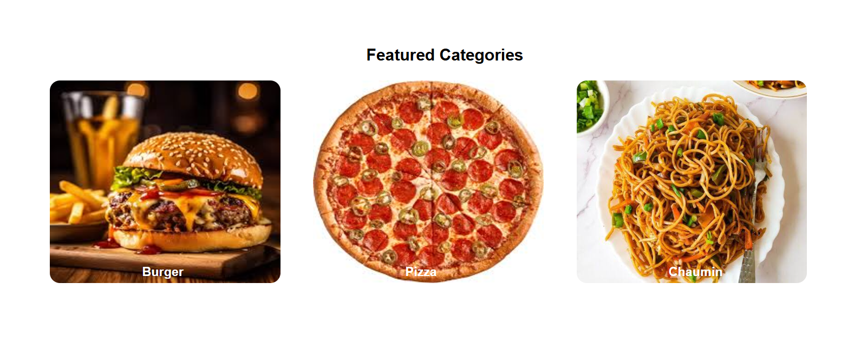

**Appendix 1: Featured Categories**

**Appendix 2: Recommended Foods**

**Appendix 3: Food Menu**

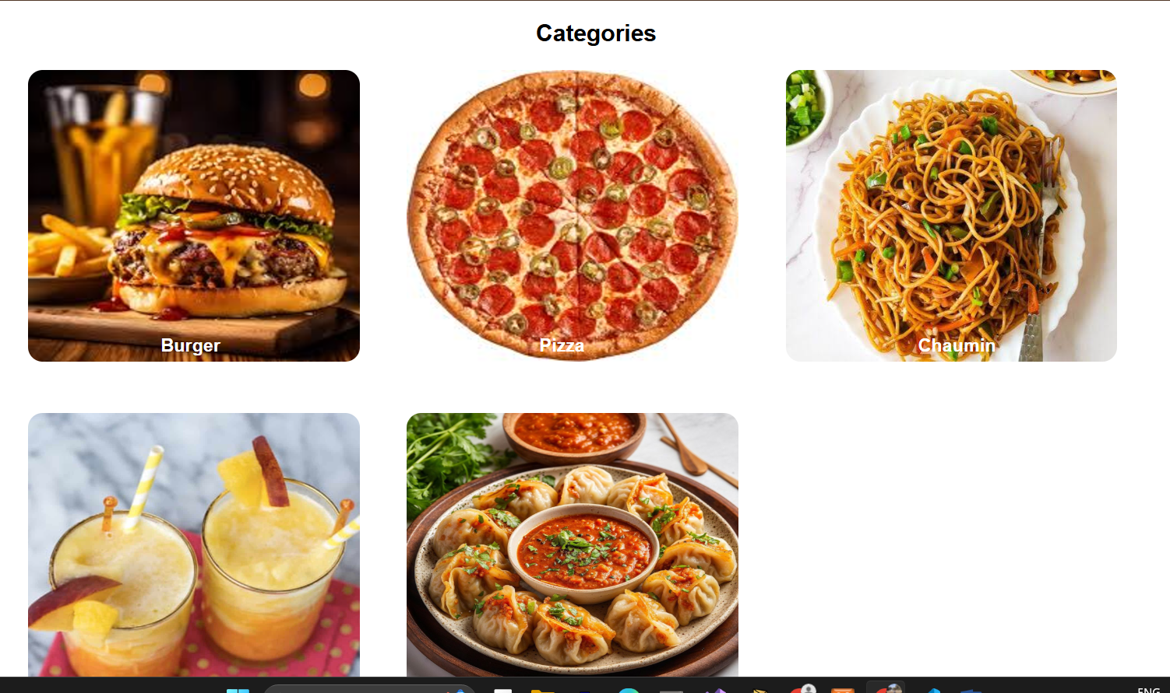

**Appendix 4: Categories**

**# About Us #**

**Appendix 5: User Login**

**Appendix 6: Manage Food**

**Appendix 7: Add Category**

**Appendix 8: Order Details**